

**Engenharia de Software (MIEI) – 2022/2023 – 1º Semestre**

**Relatório do Projeto - Fase 1**

**Engenharia de Software**

**Realizado por:**

**Grupo**

**[Bernardo Carvalho, Pedro Arruda, Ana Gadelha, Rodrigo Mesquita, Martim Costa;**

**nºs 60012, 60663, 59943, 57372, 64901]**

**Design Patterns**

**Adapter Pattern** [Pedro Arruda](mailto:pg.arruda@campus.fct.unl.pt)60633

Location:

\ganttproject\src\main\java\net\sourceforge\ganttproject\gui\options\model\CustomPropertyDefaultValueAdapter.java

This design pattern is an **adapter**. This adapter facilitates communication between two other classes.

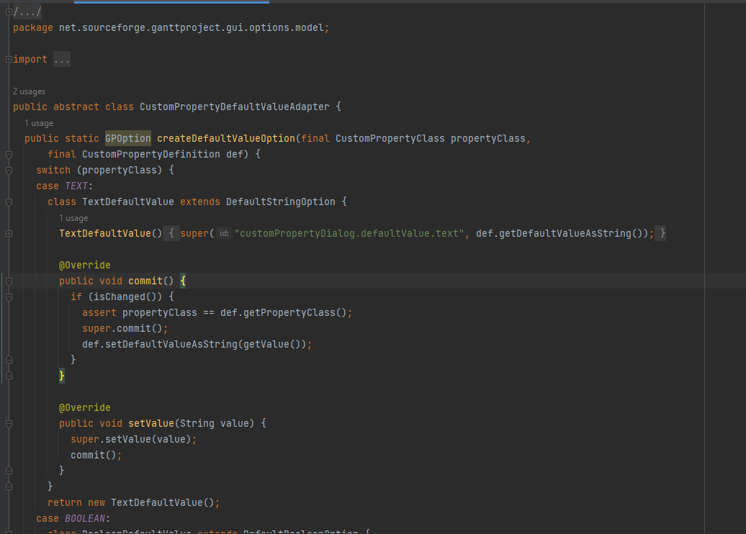

**Reviewers:**

**Singleton Pattern** [Pedro Arruda](mailto:pg.arruda@campus.fct.unl.pt)60663

Location:

\ganttproject\src\main\java\net\sourceforge\ganttproject\GanttGraphicArea.java

This design pattern is a **singleton**. With this singleton the class makes sure there can only be one instance of the object myChartComponentImpl and that it can be accessed globally.

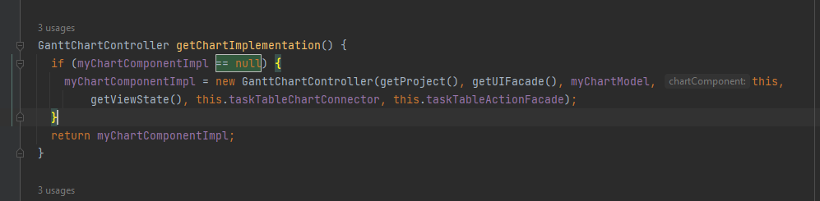

**Reviewers:**

* Reviewed by Bernardo Carvalho 60012.

**Facade Pattern** [Pedro Arruda](mailto:pg.arruda@campus.fct.unl.pt)60663

Location:

\ganttproject\src\main\java\net\sourceforge\ganttproject\gui\TreeUiFacade.java

This design pattern is a **facade**. This interface makes it much simpler to use its subsystems and results in less dependency and communication between the subsystems.

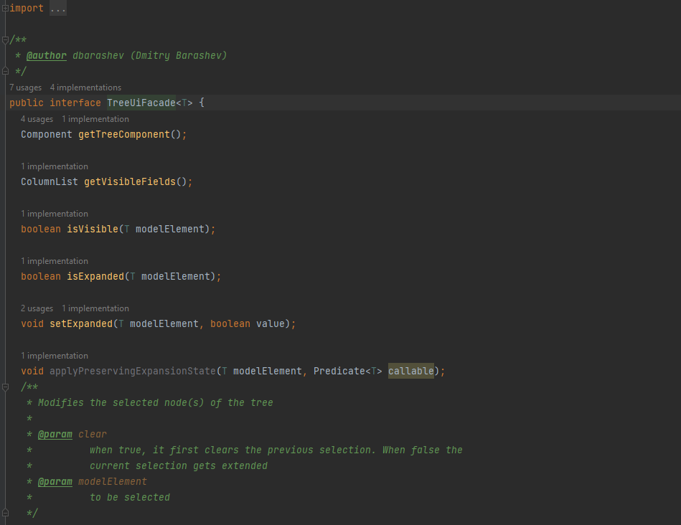

**Reviewers:**

* Reviewed by Martim Costa 64901.

**Singleton pattern** Bernardo Carvalho nº60012

Class location: \ganttproject\src\main\java\net\sourceforge\ganttproject\resource\HumanResource.java

This design pattern is a singleton because the variable myloadDistribution is only initiated on the get method which returns it.

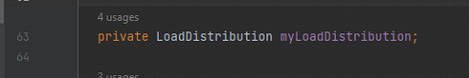

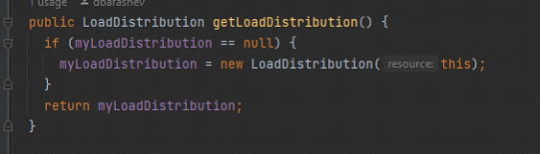

**Reviewers:**

* Reviewed by Martim Costa 64901.

**Memento pattern** Bernardo Carvalho nº60012

Class location: \ganttproject\src\main\java\net\sourceforge\ganttproject\undo\UndoableEditImpl.java

The following design pattern is known as Memento Pattern. It is used in order to return an object to one of its previous states.

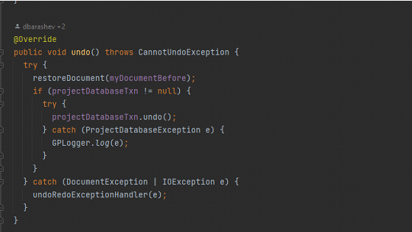

**Reviewers:**

* Reviewed by Pedro Arruda 60663.

**Adapter pattern** Bernardo Carvalho nº60012

Class location:

\ganttproject/blob/master/biz.ganttproject.desktop/src/biz/ganttproject/desktop/DesktopAdapter.java

This code pattern is the Adapter Pattern which is used to facilitate the communication between two systems of the program.

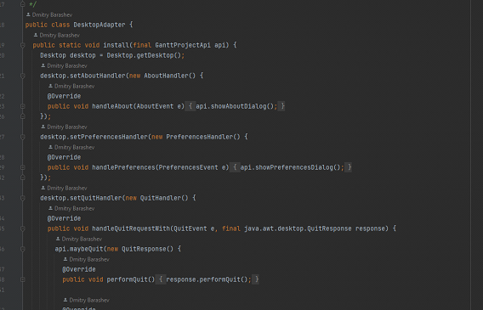

**Reviewers:**

* Reviewed by Rodrigo Mesquita 57372.

**Facade** Ana Gadelha 59943

Class Location:

ganttproject/src/main/java/net/sourceforge/ganttproject/task/TaskContainmentHierarchyFacade.java

This design pattern is a Façade. What provides a simplified interface to a set of interfaces in a subsystem, therefore it hides the complexities of the subsystems.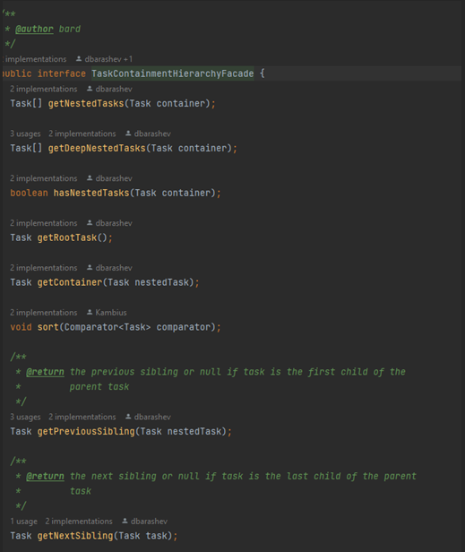

**Reviewers:**

* Reviewed by Pedro Arruda 60663.

**Factory Method** Ana Gadelha 59943

Class Location:

ganttproject/src/main/java/net/sourceforge/ganttproject/parser/ParserFactory.java

ganttproject/src/main/java/net/sourceforge/ganttproject/GanttProject.java

This design pattern is a Factory Method. It defines an interface class for creating an object but it lets the subclasses decide which class to instantiate.

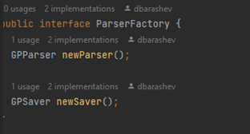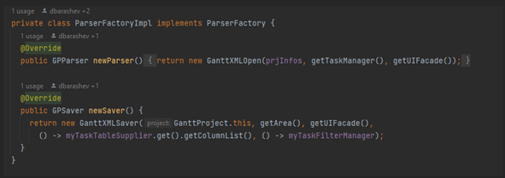

**Reviewers:**

* Reviewed by Bernardo Carvalho 60012.
* Reviewed by Rodrigo Mesquita 57372.

**Singleton** Ana Gadelha 59943

Class Location:

ganttproject/src/main/java/net/sourceforge/ganttproject/GanttOptions.java

This design pattern is a **Singleton**, because this class has only one instance and it provides a global point of access to it.

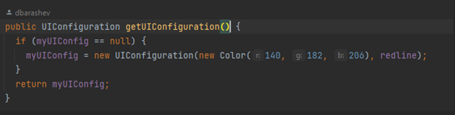

**Reviewers:**

* Reviewed by Martim Costa 64901.

**Facade** Martim Costa 64901

Interface location: \ganttproject\src\main\java\net\sourceforge\ganttproject\gui\UIFacade

Class location: \ganttproject\src\main\java\net\sourceforge\ganttproject\UIFacadeImpl

This design pattern is a **Facade**. This Facade provides a unified interface between the different managers (like the notification manager, task selection manager, zoom manager, ...) and other classes too. This way is much simpler to use the subsystems that would be a lot more complex without this Facade.

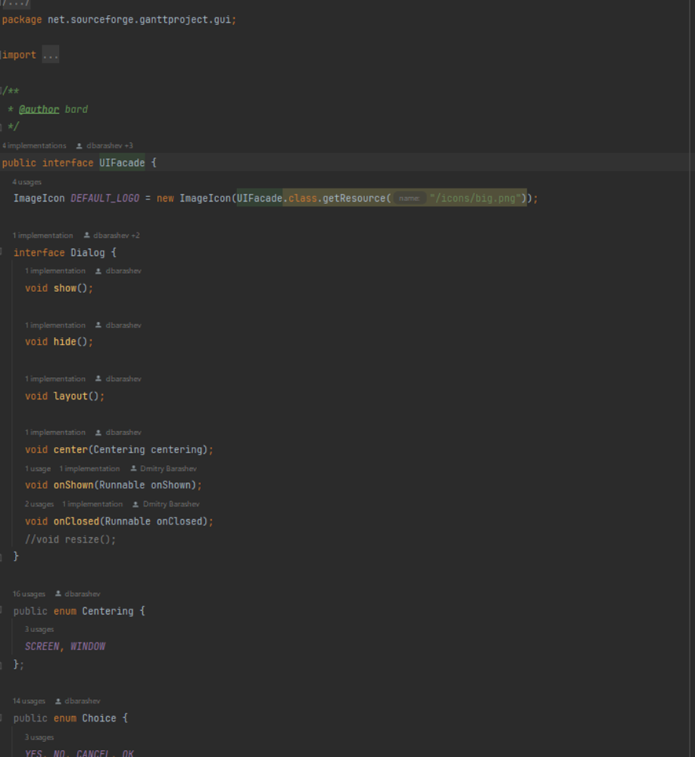

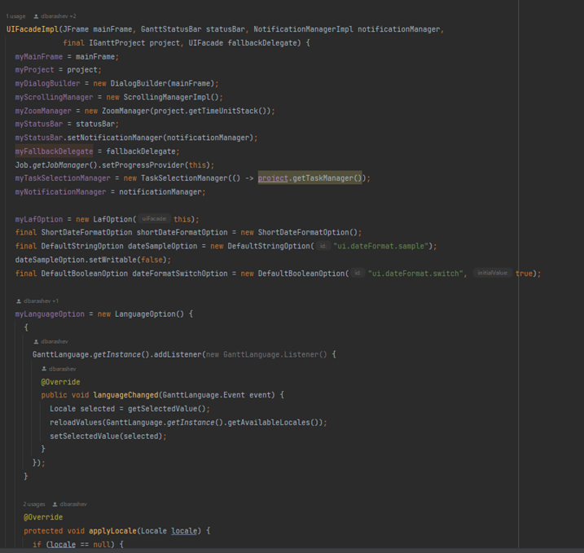

**Reviewers:**

* Reviewed by Ana Gadelha 59943.

**Proxy**  Martim Costa 64901

Location: \ganttproject\src\main\java\net\sourceforge\ganttproject\document\ProxyDocument

This design pattern is a Proxy (as the name of the class suggests). It performs the same tasks as the “original” class but in this case is used to not access directly to a document (it has a function called “getRealDocument” that will redirect to the “original” document, for example it is used in the storage of the documents).

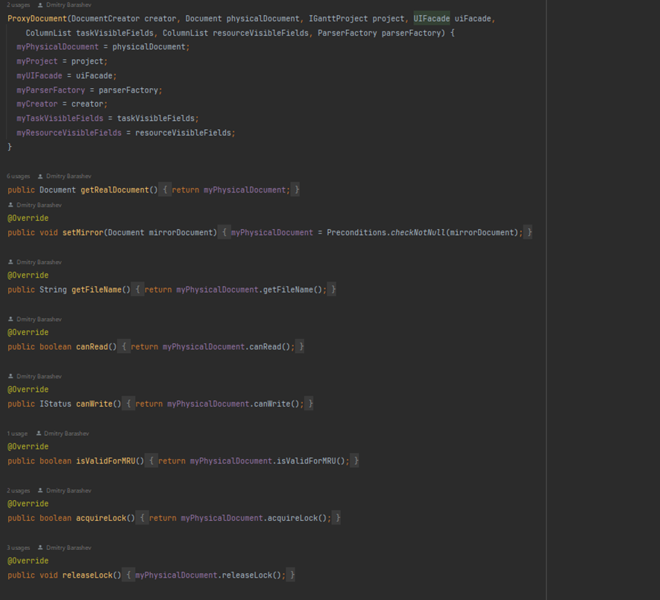

**Reviewers:**

* Reviewed by Rodrigo Mesquita 57372.

**Singleton**  Martim Costa 64901

Location: \ganttproject\src\main\java\net\sourceforge\ganttproject\gui\GattLookAndFeels

This design pattern is a Singleton. This way the class ensures no other instance is created, by intercepting requests to create new objects and provides the sole way to access the instance. It has a protected constructor, and it has the public method that instantiates the class “if” it is not already instantiated.

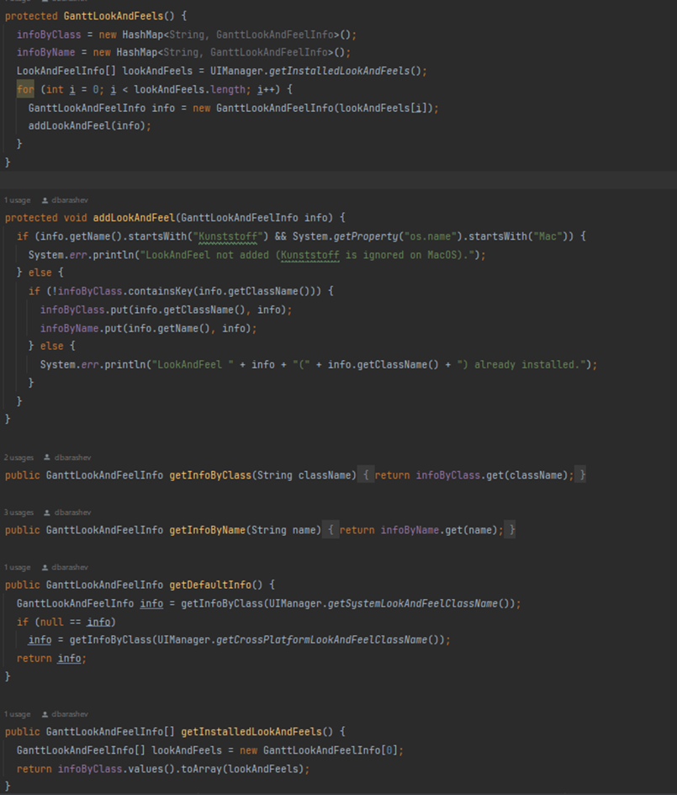

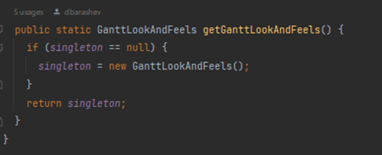

**Reviewers:**

* Reviewed by Bernardo Carvalho 60012.

**Proxy** Rodrigo Mesquita 57372

Class location:

\ganttproject\ganttproject\src\main\java\net\sourceforge\ganttproject\document\ReadOnlyProxyDocument.java

This pattern is a Proxy. It allows a proxy class to represent a real class, in this case, this proxy class represents read only documents (verified with the canRead() and canWrite() methods).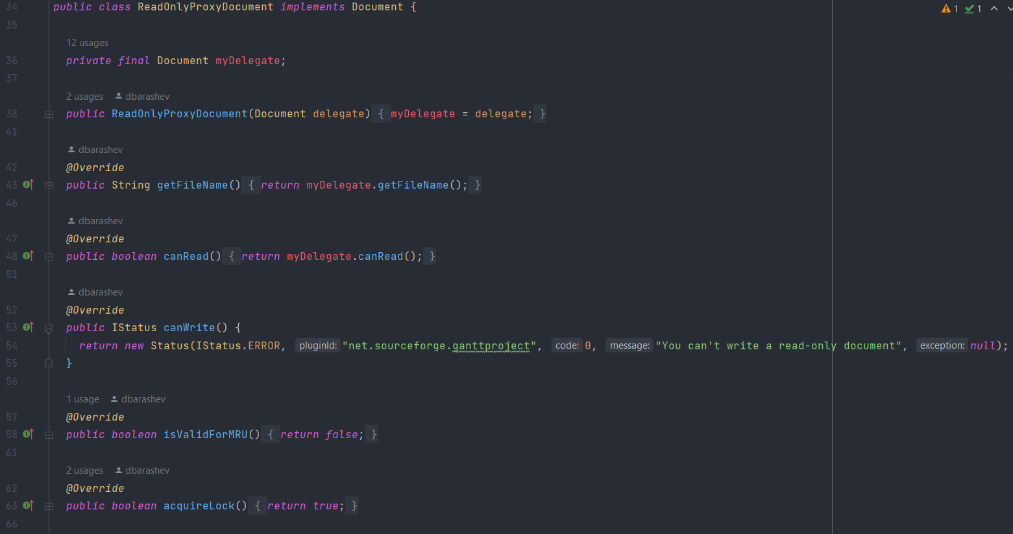

**Singleton** Rodrigo Mesquita 57372

Class location:

\Java\jdk-17.0.2\lib\src.zip!\jdk.jdi\com\sun\tools\jdi\TargetVM.java

This design pattern is a Singleton because that is the only instance in the EventController class.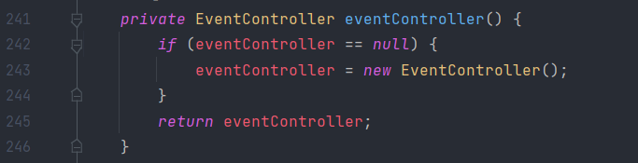

**Reviewers:**

* Reviewed by Pedro Arruda 60663.

**Facade** Rodrigo Mesquita 57372

Class location:

\ganttproject\ganttproject\src\main\java\net\sourceforge\ganttproject\chart\mouse\MouseInteraction.java

This design pattern is a Facade, it provides a simplified interface that hides the complexity of a complex subsystem.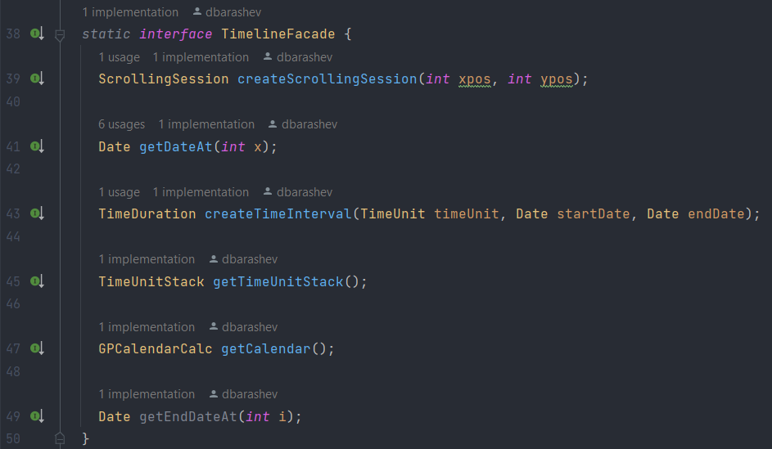

**Reviewers:**

* Reviewed by Ana Gadelha 59943.

**Code Smells**

**Dead Code** [Pedro Arruda](mailto:pg.arruda@campus.fct.unl.pt)60633

Location:

\ganttproject\src\main\java\net\sourceforge\ganttproject\PreferenceServiceImpl.java

This class is **dead code** due to it not being used and therefore should be removed to reduce code size and bring simpler support.

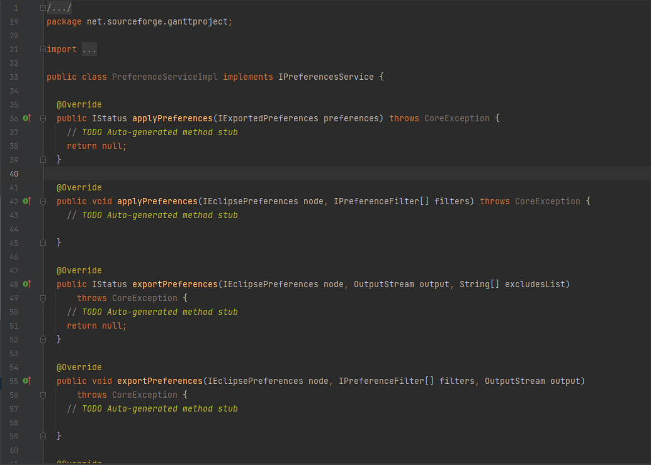

**Reviewers:**

* Reviewed by Bernardo Carvalho 60012.

**No Comments** Pedro Arruda 60663

Location:

\ganttproject\src\main\java\net\sourceforge\ganttproject\TreeTableCellEditorImpl.java

This entire class has **no comments** making it very difficult for anyone to understand what the methods/class are doing or should be doing.

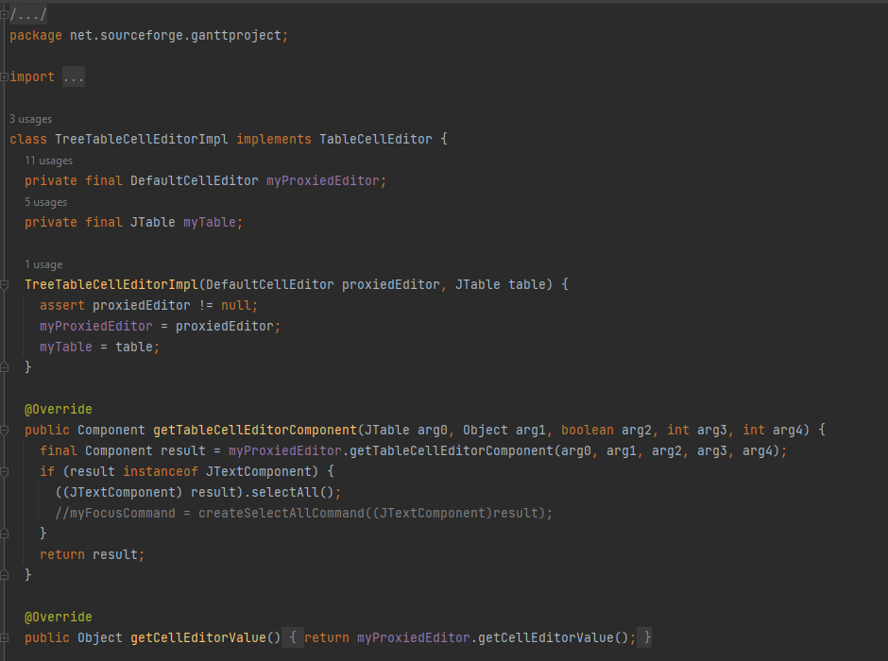

**Reviewers:**

* Reviewed by Ana Gadelha 59943.

**God Class** [Pedro Arruda](mailto:pg.arruda@campus.fct.unl.pt)60663

Location:

\ganttproject\src\main\java\net\sourceforge\ganttproject\TreeTableCellEditorImpl.java

Same class as before, this class has a **really large size** (1270 lines), turning it into a **god class** due to the amount of responsibility it has and making it even more difficult and exhausting to understand.

This class should, for example, be divided into different classes, each with its specific functionalities.

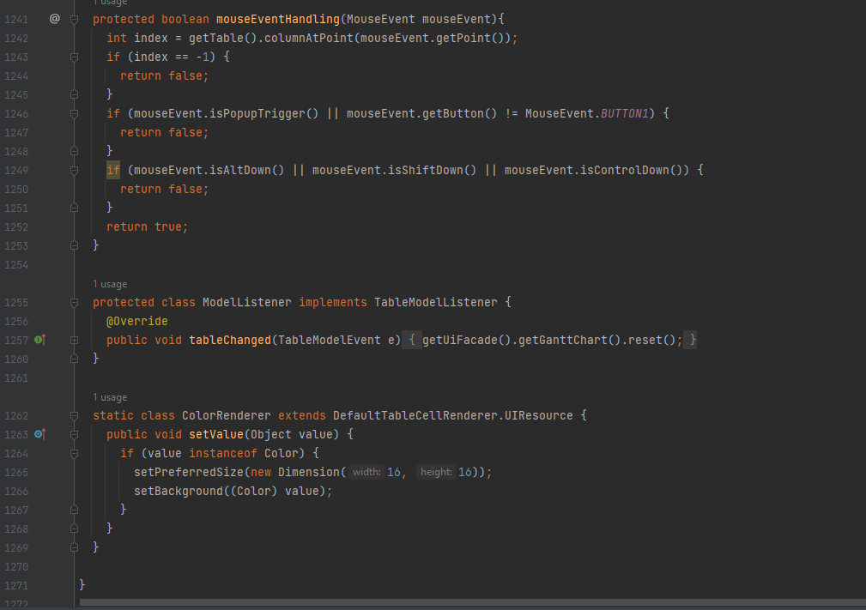

**Reviewers:**

* Reviewed by Martim Costa 64901.

**Unnecessary commentary** Bernardo Carvalho nº60012

Class location:

\ganttproject\src\main\java\net\sourceforge\ganttproject\GanttProject.java

code smell - A lot of unnecessary commentary in this method.

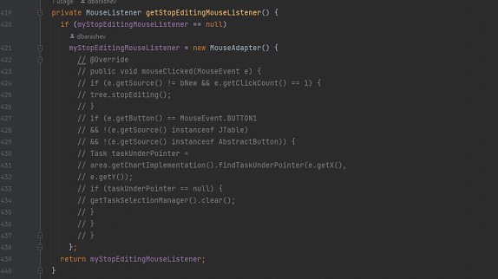

**Reviewers:**

* Reviewed by Pedro Arruda 60663.

**Massive method** Bernardo Carvalho nº60012

Class location:

\ganttproject\src\main\java\net\sourceforge\ganttproject\gui\AbstractPagesDialog.java

code smell- Massive method, perhaps there is a better way to distribute it in a group of smaller methods.



**Reviewers:**

* Reviewed by Ana Gadelha 59943.

**Very big Class** Bernardo Carvalho nº60012

Class location:

\ganttproject\src\main\java\net\sourceforge\ganttproject\gui\FileChooserPageBase.java

code smell-This class has over 400 lines of code and it’s not even the system. Perhaps it should be spread out between smaller classes.



**Reviewers:**

* Reviewed by Martim Costa 64901.
* Reviewed by Rodrigo Mesquita 57372.

**Dead Code** Ana Gadelha 59943

Class Location:

ganttproject/src/main/java/net/sourceforge/ganttproject/action/project/CloudProjectActionBase.java

This class is Dead Code because it is never used, it should be removed, to simplify the code and reduce the code size.

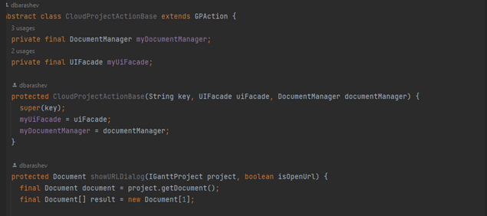

**Reviewers:**

* Reviewed by Martim Costa 64901.

**Long Parameter List** Ana Gadelha 59943

Class Location:

ganttproject/src/main/java/net/sourceforge/ganttproject/chart/gantt/GanttChartController.java

This constructor has too many arguments, which can indicate that this class has more functionalities than what it should have.

A way to make it simpler would be to aggregate some of the arguments into a class, and then the constructor would only have to receive one argument instead of receiving them individually.

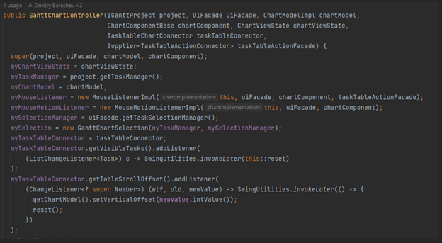

**Reviewers:**

* Reviewed by Bernardo Carvalho 60012.

**Unnecessary Comments** Ana Gadelha 59943

Class Location:

ganttproject/src/main/java/net/sourceforge/ganttproject/chart/ChartModelImpl.java

This class has a lot of unnecessary comments, which can be confusing, and also mean that the method is too complex, what causes the need to exaggerate on the comments.

A solution to this would be to remove the unnecessary comments and simplify the method so tat it does not need such an explanation.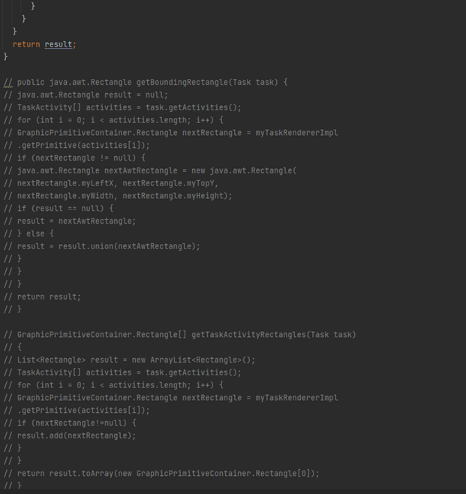

**Reviewers:**

* Reviewed by Pedro Arruda 60663.

**Huge Function**  Martim Costa 64901

Location: \ganttproject\src\main\java\net\sourceforge\ganttproject\application\MainApplication

This function has a large size (around 88 lines), making it difficult and exhausting to understand the processes that are happening.

My suggestion to improve and refactor this code is to create smaller methods to decrease the size of this function, making it easier to read and debug.

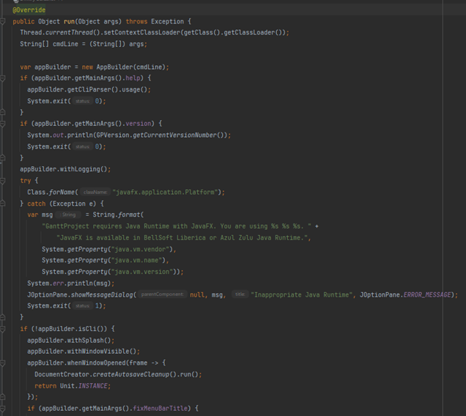

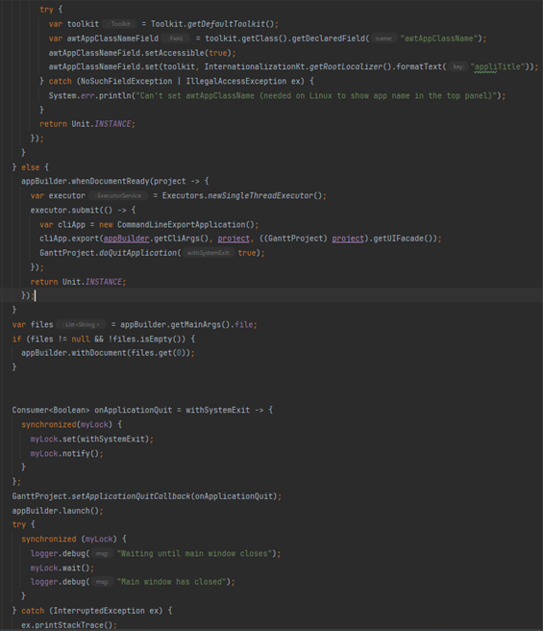

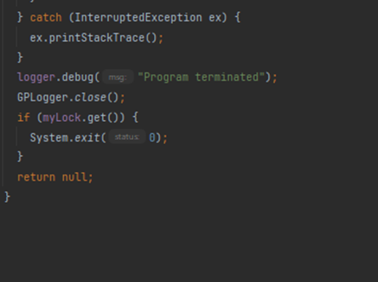

**Reviewers**:

* Reviewed by Bernardo Carvalho 60012.

**Excessively long identifiers**  Martim Costa 64901

Location: \ganttproject\src\main\java\biz\ganttproject\impex\csv\GanttCVSExport

This class has variables with excessively long identifiers, making it harder to read and use.

My suggestion is to reduce the size of the identifiers, using naming conventions of software architecture, reducing the effort to read and understand the code, and enable code reviews to have more focus on more important issues than naming and syntax standards. One example could be deleting the “Human” and using only a “H” and then comment above what the “H” means.

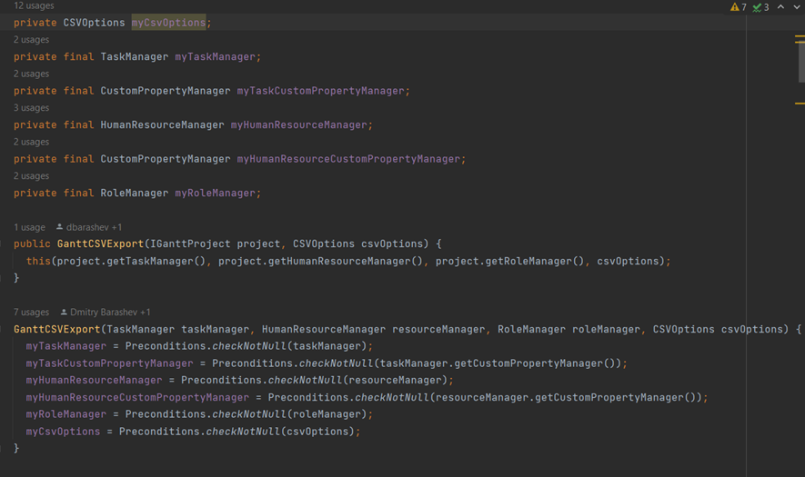

**Reviewers**:

* Reviewed by Rodrigo Mesquita 57372.

**Constructor with too many arguments**  Martim Costa 64901

This constructor has too many arguments (10), making it hard to debug, and probably meaning that this Class is doing more than it should.

One possible way to improve this is to define a class which holds these parameter values and re-phrase the constructor to accept the class instance as a parameter instead of individually requesting the parameters.

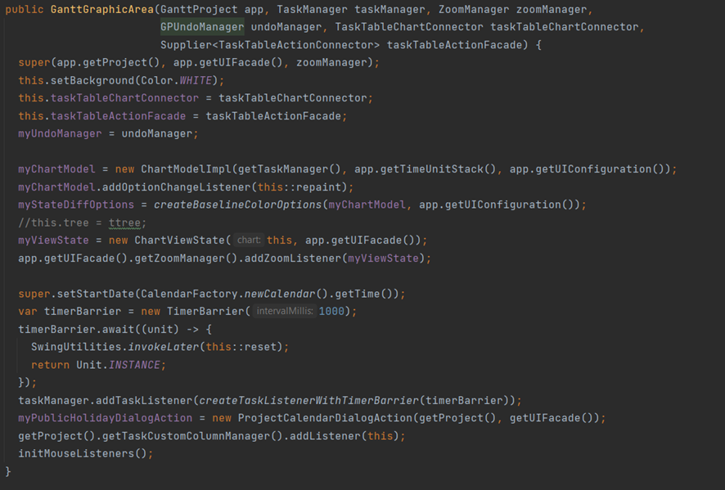

**Reviewers:**

* Reviewed by Rodrigo Mesquita 57372.

**No Comments**  Rodrigo Mesquita 57372

Smell Code Location:

\ganttproject\ganttproject\src\main\java\net\sourceforge\ganttproject\calendar\CalendarEditorPanel.java

This class has 513 lines of code with many methods for different purposes, but there are no comments to explain their functionalities, which makes it hard and exhaustive to understand the code to someone new or even to the original developer.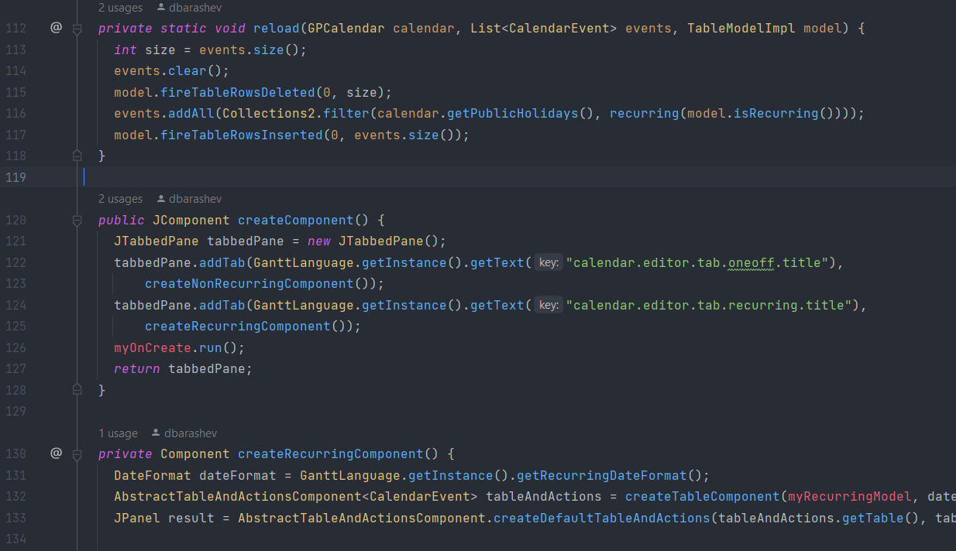

**Reviewers:**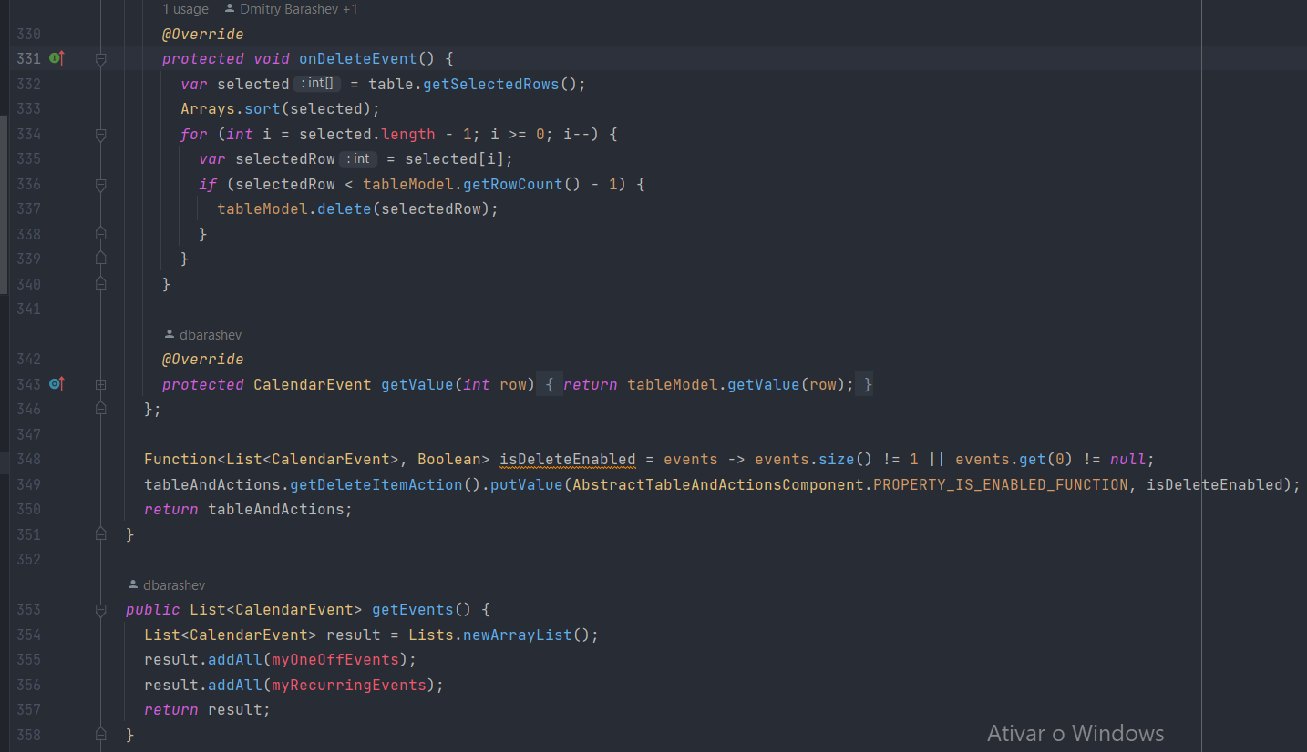

* Reviewed by Pedro Arruda 60663.

**Dead Code**  Rodrigo Mesquita 57372

Smell Code Location:

\ganttproject\ganttproject\src\main\java\net\sourceforge\ganttproject\filter\GanttXMLFileFilter.java

This is an example of Dead Code. In this case, the class and its constructor are never used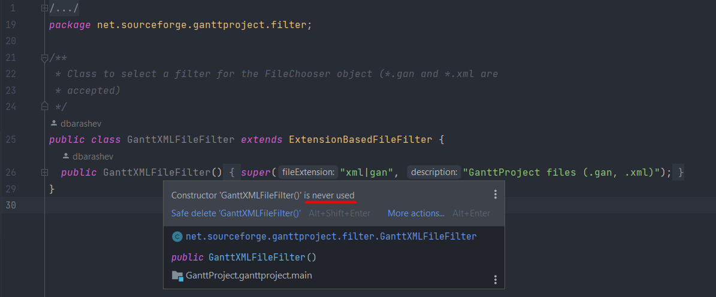

**Reviewers:**

* Reviewed by Ana Gadelha 59943.

**Large Class** Rodrigo Mesquita 57372

Smell code location:

\ganttproject\ganttproject\src\main\java\net\sourceforge\ganttproject\task\algorithm\DependencyGraph.java

This is an example of a Large Class. This is a result of accumulating responsibilities that require extensive comments (another code smell) to document where in the code of the class certain functionalities exist.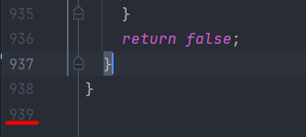

**Reviewers:**

* Reviewed by Martim Costa 64901.